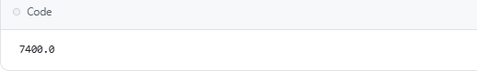Create a Python function that converts an amount from one currency to another using exchange rates stored in a dictionary. Use GitHub Copilot along with VS Code. Use few shots prompting.

# Step 2: Prompt

"Write a Python function that converts an amount from one currency to another using a dictionary of exchange rates."

# Step 3: Code

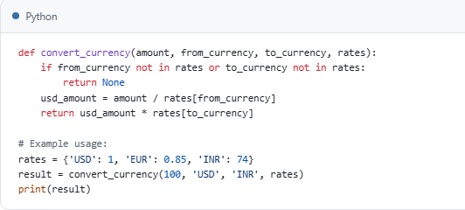

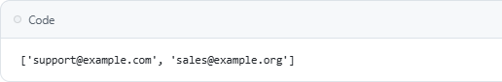Write a Python program to extract all email addresses from a block of text using regular expressions. GitHub Copilot along with VS Code. Use zero shot prompting.

# Step 2: Prompt

"Extract all email addresses from a given text using Python regular expressions."

# Step 3: Code

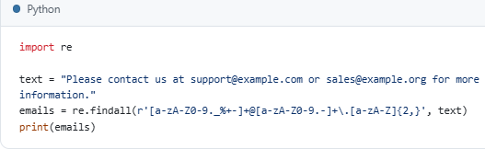

Step 1: Question Given a list of movies with their genres, write a Python function that recommends movies based on a user’s preferred genre. Use the Cursor AI tool. Use few-shot prompting.

Step 2: Prompt" Few-shot examples:

* Input: movies= [('Inception ','Sci-Fi'), ('Titanic', 'Romance')], preferred='Sci-Fi' → Output: ['Inception']
* Input: movies = [('Dune',' Sci-Fi'), ('Up',' Animation')], preferred='Animation' → Output: ['Up']

Task: Write a Python function that takes a list of (movie, genre) tuples and a preferred genre and returns a list of movies matching that genre.

"Step 3: Code

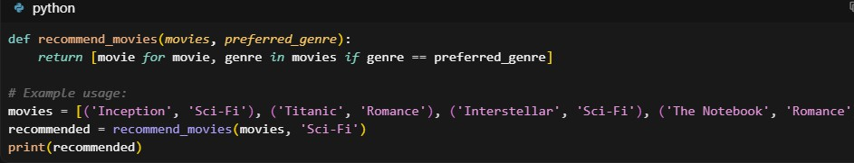+

Step 1: Question Write Python code that reads a CSV file containing student names and marks in 3 subjects. Calculate the total and average marks for each student. Use the Cursor AI tool.

Step 2: Prompt" Write Python code to read a CSV file with student names and marks for 3 subjects, then print each student's total and average marks.

Step 3: Code

